**Deployment Manual**

**Project title: Student Management System**

**Team members:**

1. Mohammed Ashik
2. Prem kumar
3. Neethu devis
4. Harish
5. Najula M N
6. Prakash
7. *The* ***GitHub Public Repository Link*** *for the Project* ***Student Management System*** 
   1. **GitHub Link:** <https://github.com/AshikTechB/Student_Management_System.git>
8. ***Additional Requirements***

* Passwords Used:
  1. *Oracle Database Credentials:*
  + Username= SYSTEM
  + Password= project

*2.2 Application Default Login Credentials:*

* + Username= Admin
  + Password= Admin123
  + Username= User
  + Password= User123

*2.3 Port Numbers used in Application:*

* + Spring Boot Application Tomcat Server Port Number = 9090
  + Angular Application Port Number = 4207

*2.4 Angular Application Main Application Run Link:*

* + Link = <http://localhost:4207>

1. ***Version of Tech Stack***

* Angular --- 8
* Spring Boot --- 2.5.10
* Java --- 8
* JDK – 1.8
* Oracle Database --- 11g

1. ***Steps To Add Project in local work Space from GitHub Using Git Bash***

GitBash 🡪 We are using GitBash for working in the GitHub

STEP 1: Download the GitBash in your system.

STEP 2: Create an empty workspace for the git project to be cloned (optional)

STEP 3: Open GitBash 🡪 use the command cd <path of the directory you want to clone the project with ‘/’ instead of ‘\’>

STEP 4: Copy Link of GitHub Code then in Git Bash use git clone and paste the link

$ git clone <https://github.com/AshikTechB/Student_Management_System.git>

[ The Git Hub project is cloned in the developer system]

**(sample)**

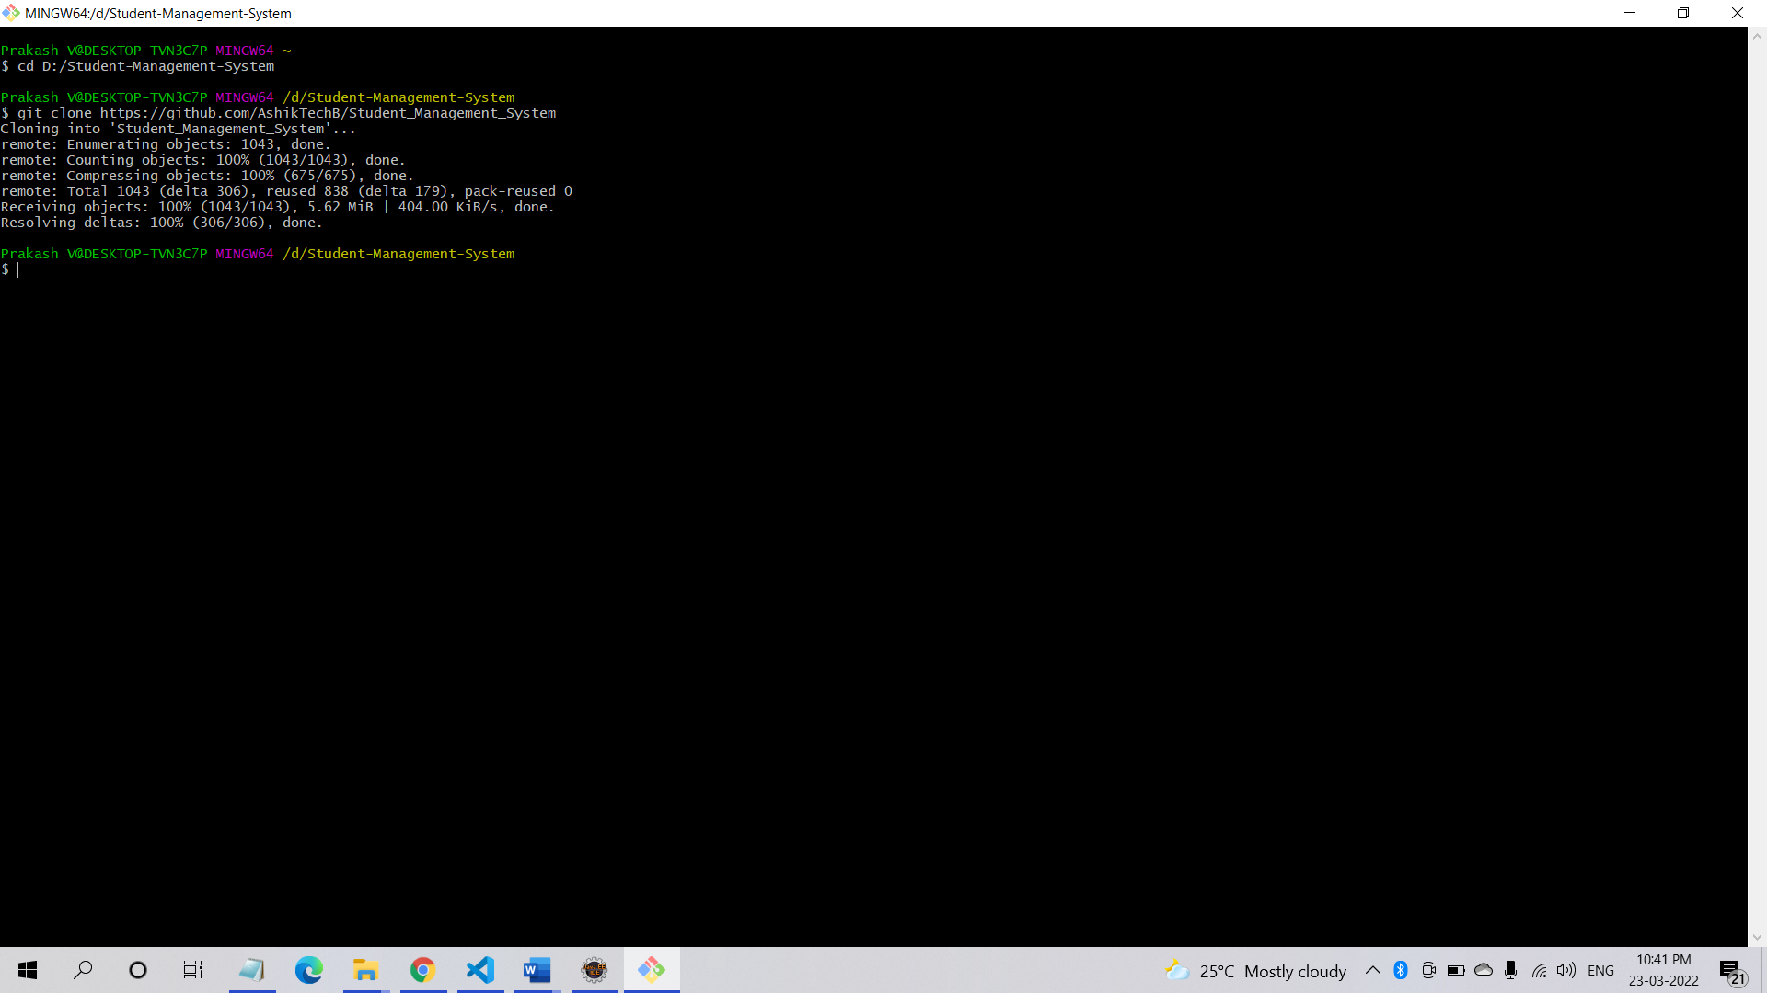

1. ***How to import Project in ECLIPSE IDE***

STEP 1: Go ECLIPSE WORKSPACE, **file**🡪**Open Project from File System**

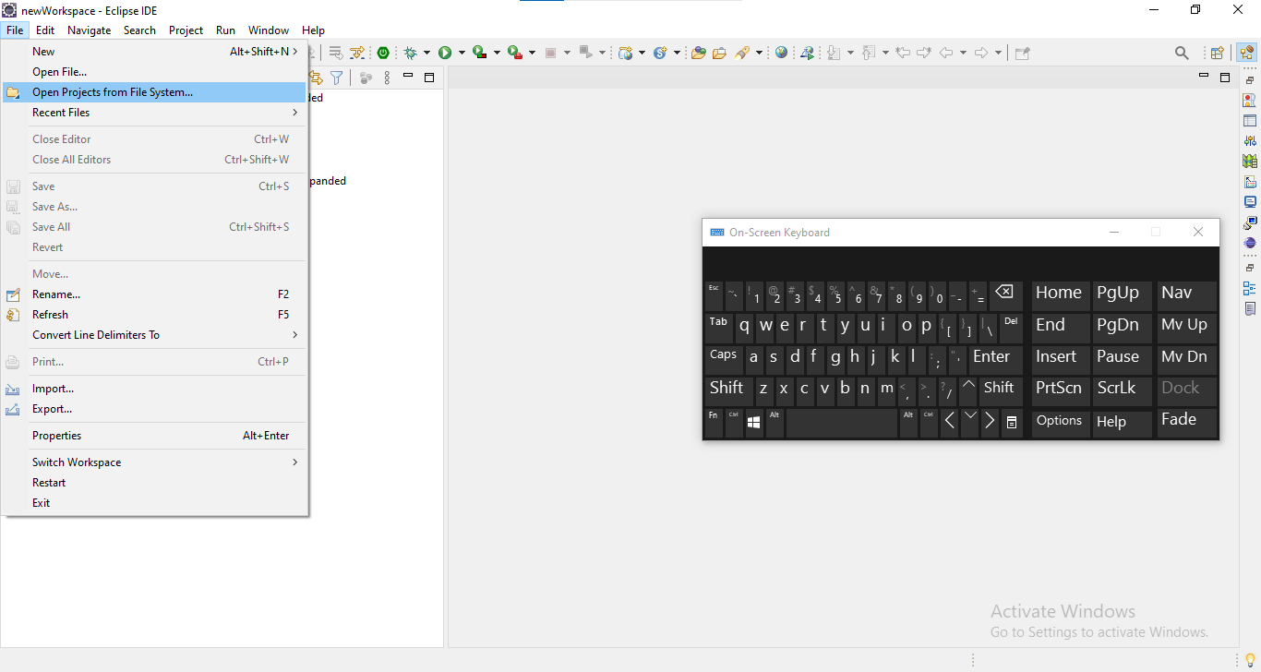

STEP 2: Then go to your workspace folder from directory 🡪 Select the cloned project from the directory 🡪 Finish

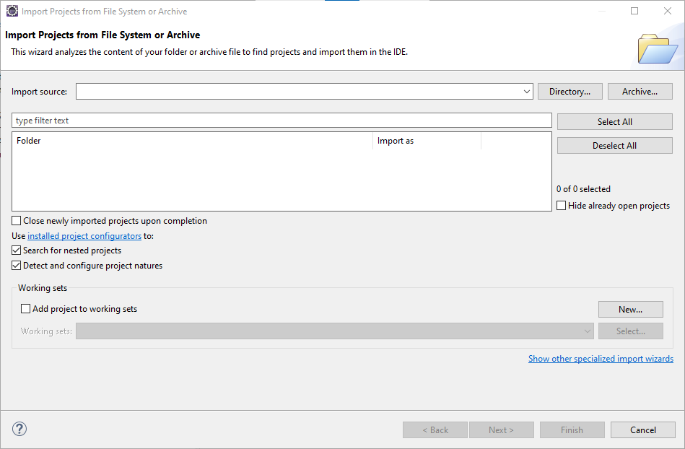

Following the above steps, you can import the project successfully in your ECLIPSE IDE workspace

1. ***Database***

1. We have to Download Oracle 11g and SQL developer

2. Then we can create tables student, user_detail

* 1. *GitHub link for the Database script:*

[***https://github.com/AshikTechB/Student_Management_System/blob/main/Student_Management_System/src/main/resources/dbscript.sql***](https://github.com/AshikTechB/Student_Management_System/blob/main/Student_Management_System/src/main/resources/dbscript.sql)

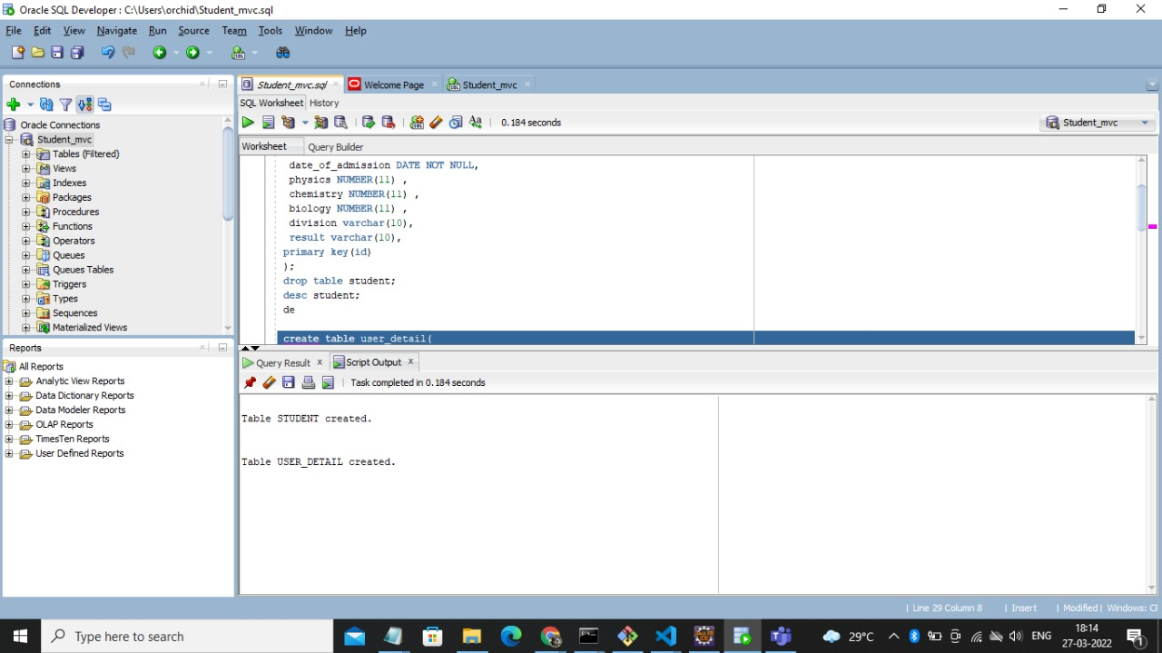

1. ***How to run the project in Eclipse IDE***

STEP 1: Go to the project folder

STEP 2: Then right click on the project name

STEP 3: Then go to Run As option

STEP 3.1: Click on Maven Clean

**Maven clean:**

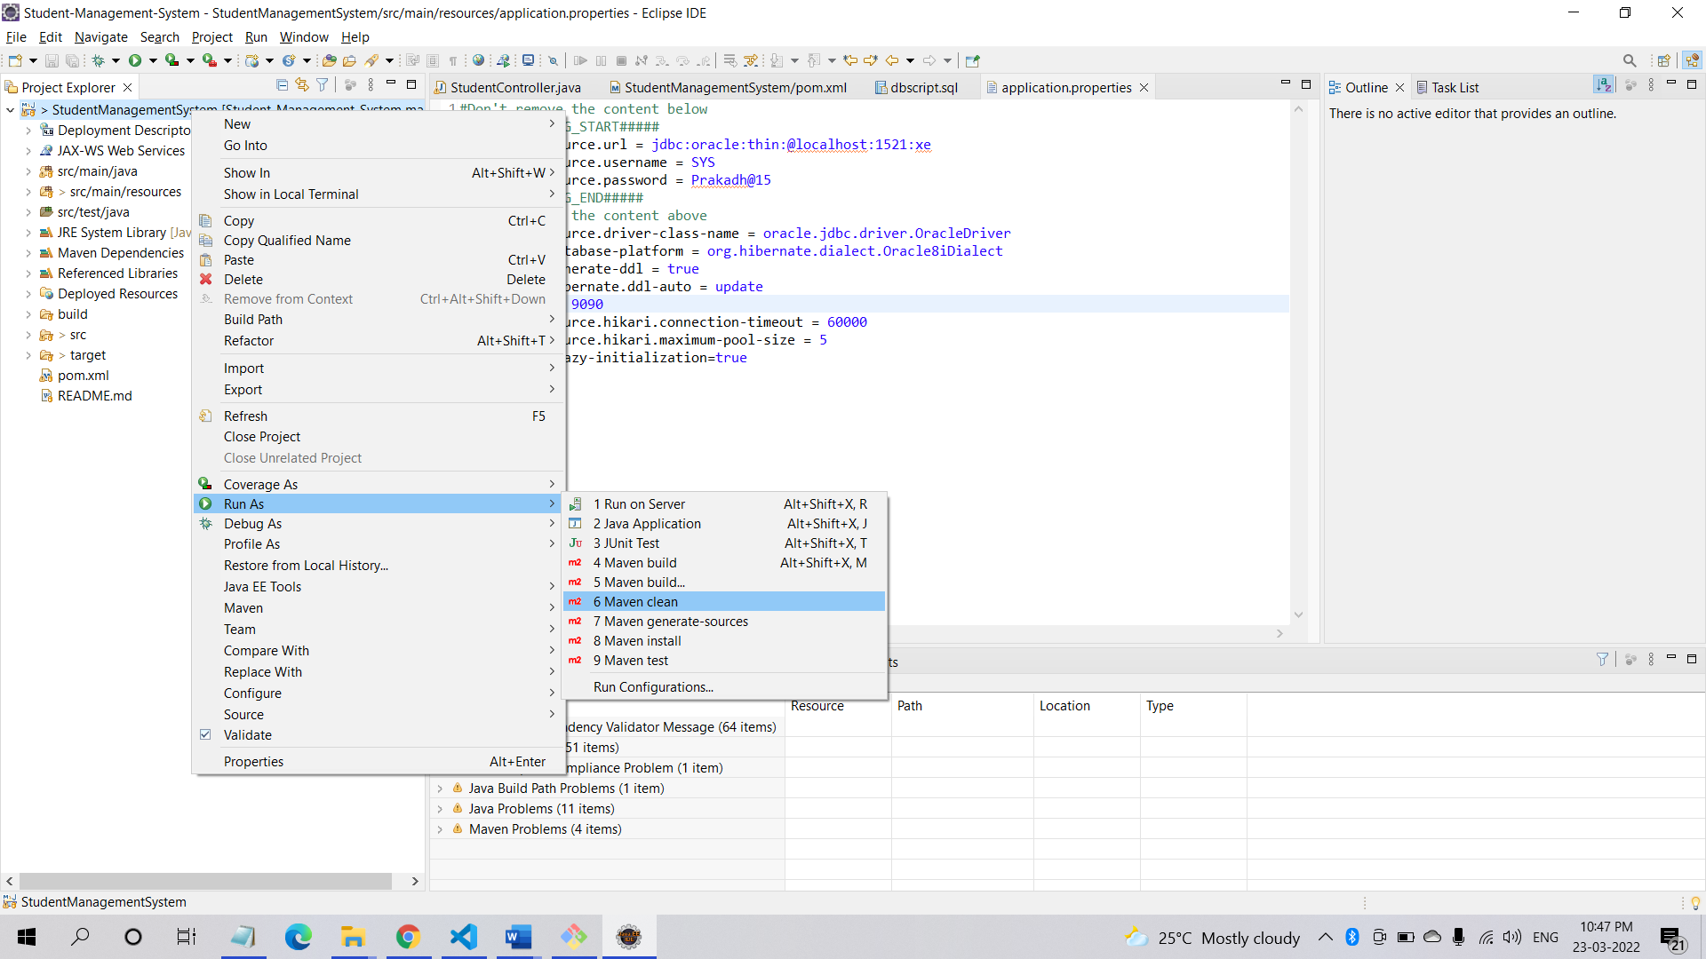

STEP 3.1.1: Check the Console, **BUILD SUCCESS** message should be displayed

**Maven Clean Success:**

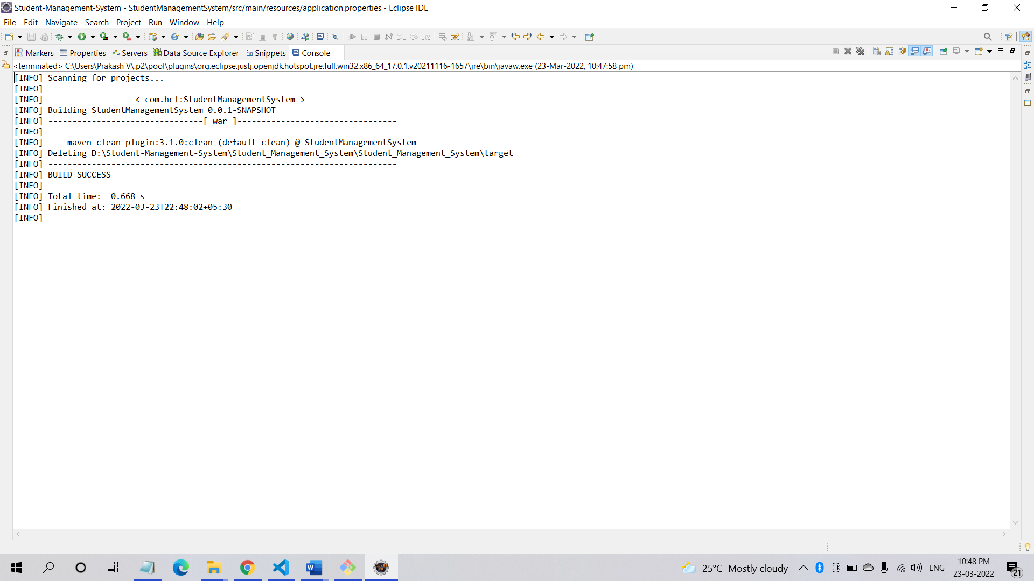

STEP 3.2: Click on **Maven Build**

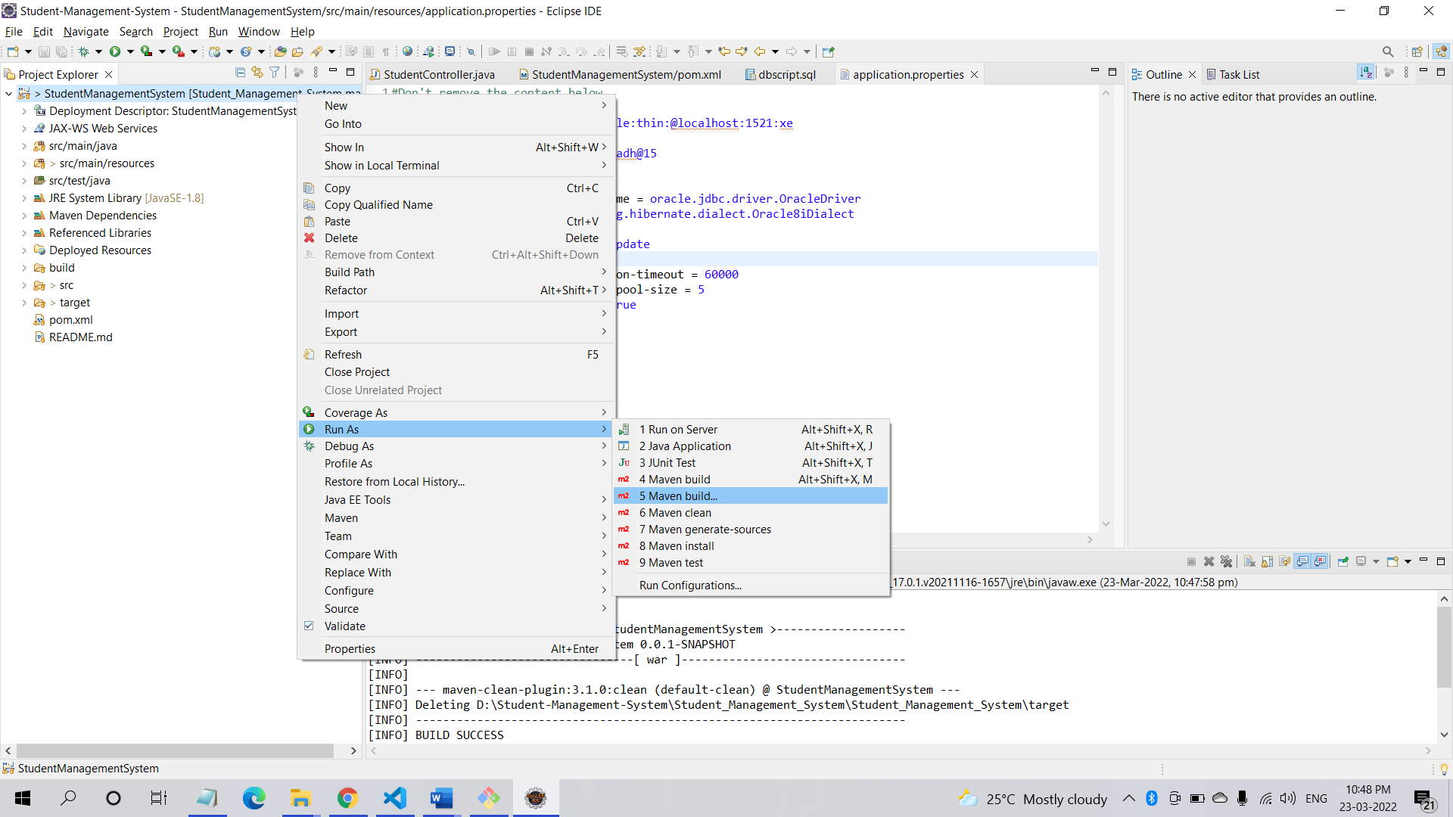

STEP 3.2.1: An Edit Configuration window will open; there a Goal option is found write **“clean install”** in the input space of goal. Also click on the **Skip Tests** checkbox. Then click on apply button, after that run button.

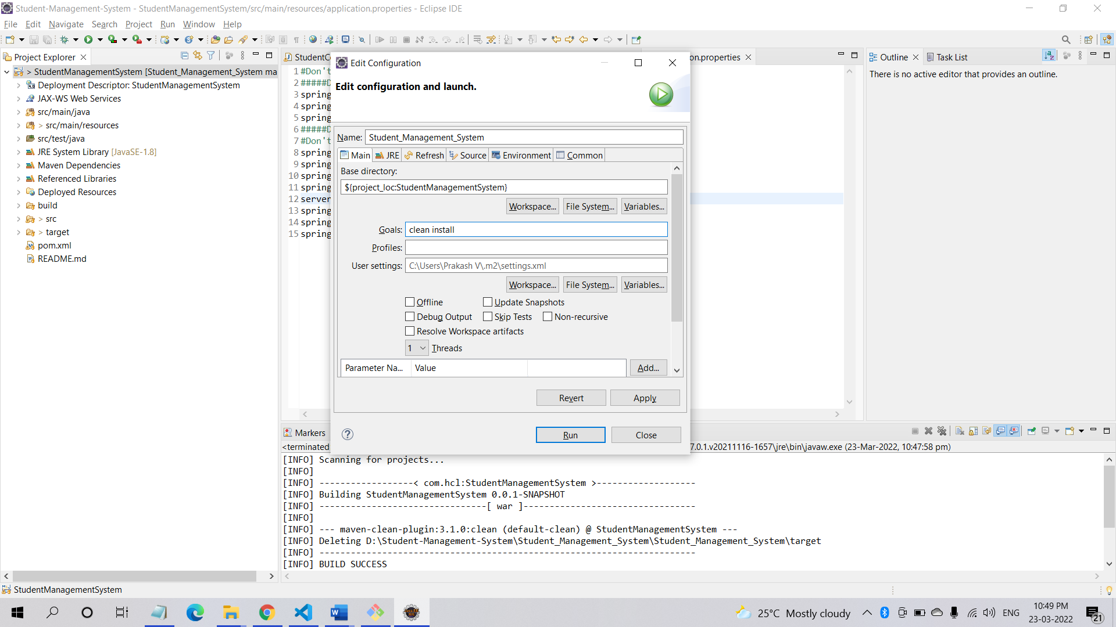

STEP 3.2.2: Right Click on the project name 🡪 Click on ‘**Refresh’**

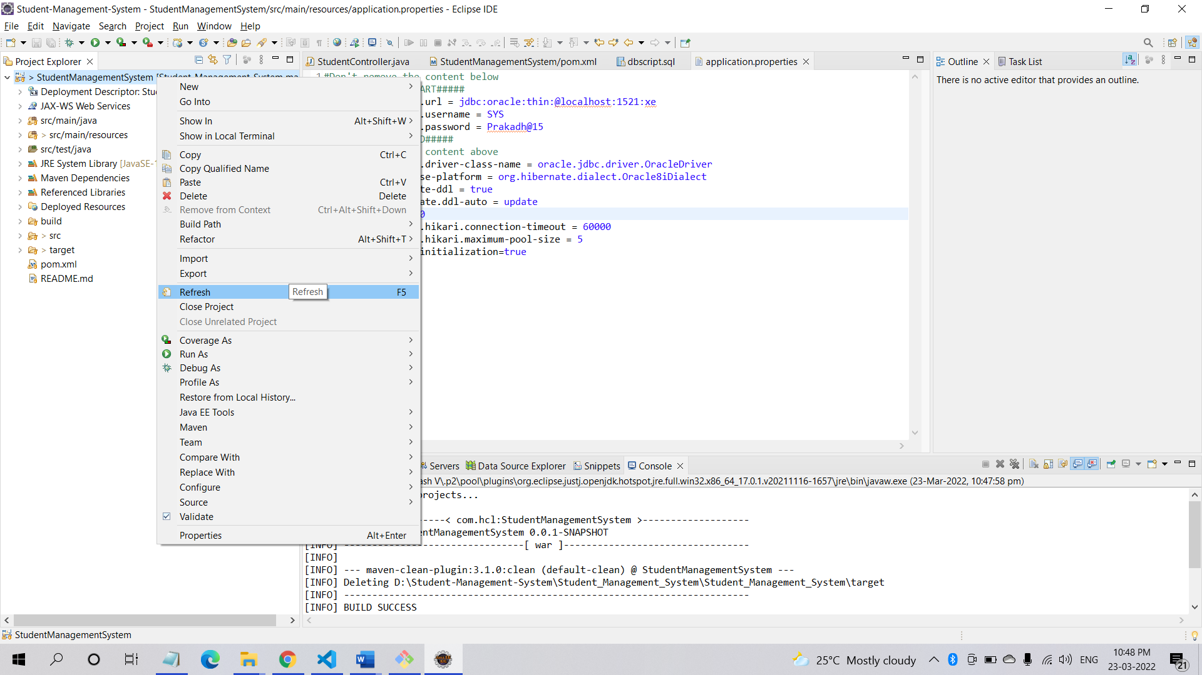

STEP 3.2.2: Check the Console, **BUILD SUCCESS** message should be displayed.

**Maven Build success:**

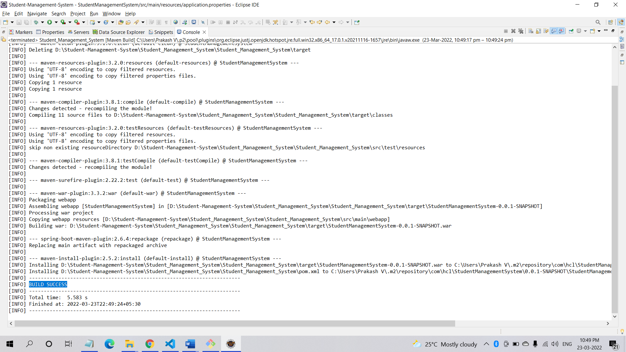

STEP 4: Go to src/main/java 🡪 com.hcl (package) 🡪 StudentRestApplication.java . Right click and Run As “Java Application”

1. ***How to run Angular using Command Prompt (CMD)***

STEP 1: Download and install Node.js (including NPM) in windows system

<https://nodejs.org/en/download/>

STEP 2: Go to Command Prompt

STEP 3: Command to check the Node.js version installed in system: **node -v**

STEP 4: Install the Angular CLI: **npm install -g @angular/cli**

STEP 5: Command to check Angular version installed in your system: ng –version

STEP 6: Go to GitHub Cloned Folder to webapp/view

STEP 7: Copy the path by right click on **View 🡪 Properties**

STEP 8: Use the command “**cd <paste the copied path>”**

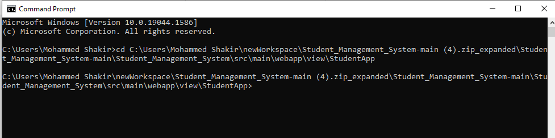

STEP 9: Once the installation is successful run the **“ng serve –port 4207”** command. (Angular by Default uses port 4200 but as we are using 4207 port for our project so we have to change the port number manually).

STEP 10: Once the compilation is successful in the command prompt a URL is displayed, copy that and paste it in your browser.

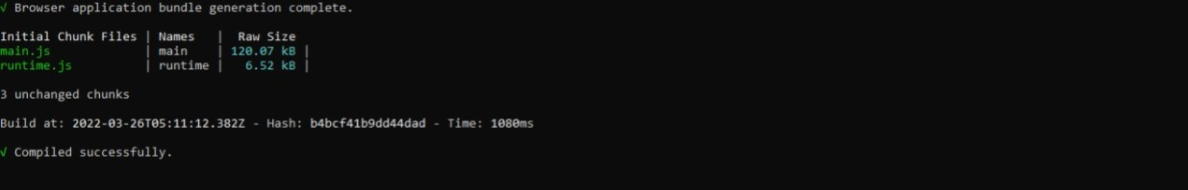

STEP 9: By default, the URL is set to display the login page. So, it will display a login page.

1. ***Project Testing / Access:***

STEP 1. Open URL : <http://localhost:4207/> from browser

STEP 2. To login into the application use Default Login Username and Default Login Password.

STEP 3. Once you successfully log into the application, you can use the below application functionalities:

* Login/Register for User
* Search Student by ID
* Update Student by ID
* Register a new student by User
* Delete a student
* Logout for user